Dictionary-Style Thesaurus

What is Dictionary-Style Thesaurus
# Source: AI Source: Provided by: [Data Path: Persons Table -> ID Column: 1, Name_En Column: Motasem Essam] -> From: [Chatgpt (GPT-4-turbo)] on [7/29/2025]
A Dictionary-Style Thesaurus presents synonyms and antonyms in alphabetical order, much like a standard dictionary. Unlike the traditional concept-based format (like Roget’s), this type is word-based, making it easier and faster for users to look up specific entries directly.

🔹 Key Features of a Dictionary-Style Thesaurus
# Source: AI Source: Provided by: [Data Path: Persons Table -> ID Column: 1, Name_En Column: Motasem Essam] -> From: [Chatgpt (GPT-4-turbo)] on [7/29/2025]
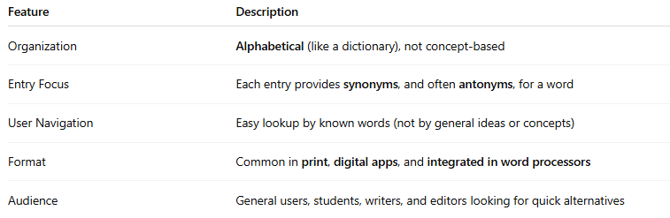
Feature | Description
Organization | Alphabetical (like a dictionary), not concept-based
Entry Focus | Each entry provides synonyms, and often antonyms, for a word
User Navigation | Easy lookup by known words (not by general ideas or concepts)
Format | Common in print, digital apps, and integrated in word processors
Audience | General users, students, writers, and editors looking for quick alternatives

🔹 Structure Example
# Source: AI Source: Provided by: [Data Path: Persons Table -> ID Column: 1, Name_En Column: Motasem Essam] -> From: [Chatgpt (GPT-4-turbo)] on [7/29/2025]
An entry might look like:
Happy
Synonyms: joyful, content, delighted, cheerful
Antonyms: sad, miserable, gloomy

🔹 Well-Known Examples
# Source: AI Source: Provided by: [Data Path: Persons Table -> ID Column: 1, Name_En Column: Motasem Essam] -> From: [Chatgpt (GPT-4-turbo)] on [7/29/2025]
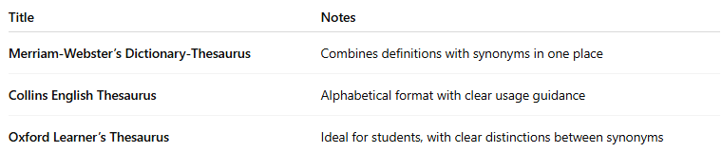
Title | Notes
Merriam-Webster’s Dictionary-Thesaurus | Combines definitions with synonyms in one place
Collins English Thesaurus | Alphabetical format with clear usage guidance
Oxford Learner’s Thesaurus | Ideal for students, with clear distinctions between synonyms

🔹 Advantages
# Source: AI Source: Provided by: [Data Path: Persons Table -> ID Column: 1, Name_En Column: Motasem Essam] -> From: [Chatgpt (GPT-4-turbo)] on [7/29/2025]
- Faster and more user-friendly than traditional concept-based thesauruses
- Ideal for everyday writing, editing, and learning
- Easy integration with word processing tools (e.g., MS Word Thesaurus)
- Often includes definitions, usage examples, and part of speech labels

🔹 Limitations
# Source: AI Source: Provided by: [Data Path: Persons Table -> ID Column: 1, Name_En Column: Motasem Essam] -> From: [Chatgpt (GPT-4-turbo)] on [7/29/2025]
- Less helpful for brainstorming or conceptual exploration
- May miss semantic relationships that traditional thesauruses highlight

